

ОТЧЕТ

о выполнении практической (лабораторной) работы

Наследование классов

Выполнили:

2ИСП 11-24Вб

Дубцова С.А.

Муратов С.С

Проверил: преподаватель

Карпов Р.В.

2022

Оглавление

Код программы 3

Диаграмма классов 7

Вывод 7

# Код программы

#include <iostream>

#include <string>

using namespace std;

class Human {

public:

int weight, height, age;

string name, education;

void setWeigth(int weight) {

if (weight > 0) {

this->weight = weight;

}

else {

cout << "Error" << endl;

}

}

void setHeigth(int height) {

if (height > 0) {

this->height = height;

}

else {

cout << "Error" << endl;

}

}

void setAge(int age) {

if (age >= 18) {

this->age = age;

}

else {

cout << "Error" << endl;

}

}

void setName(string name) {

if (name == "") {

cout << "Error" << endl;

}

else {

this->name = name;

}

}

void setEducation(string education) {

if (education == "") {

cout << "Error" << endl;

}

else {

this->education = education;

}

}

int getWeight() {

return weight;

}

int getHeight() {

return height;

}

int getAge() {

return age;

}

string getName() {

return name;

}

string getEducation() {

return education;

}

void getInfo() {

cout << "Name: " << getName() << endl

<< "Age: " << getAge() << endl

<< "Weight: " << getWeight() << endl

<< "Height: " << getHeight() << endl

<< "Education: " << getEducation() << endl;

}

};

class Person : public Human {

public:

string resume;

int skills;

void setResume(string resume) {

this->resume = resume;

}

void setSkills(int skills) {

if (skills > 0) {

this->skills = skills;

}

else {

cout << "Error" << endl;

}

}

string getResume() {

return resume;

}

int getSkills() {

return skills;

}

void getInfo() {

Human::getInfo();

cout << "Resume: " << getResume() << endl

<< "Skills: " << getSkills() << endl;

}

};

class Employ : public Human {

public:

string workExperience;

int seniority;

void setWorkExperience(string workExperience) {

this->workExperience = workExperience;

}

void setSeniority(int seniority) {

if (this->workExperience == "") {

this->seniority = 0;

}

else if (seniority > 0) {

this->seniority = seniority;

}

else {

cout << "Error" << endl;

}

}

string getWorkExperience() {

return workExperience;

}

int getSeniority() {

return seniority;

}

void getInfo() {

Human::getInfo();

cout << "Work expirience: " << getWorkExperience() << endl

<< "Seniority: " << getSeniority() << endl;

}

};

int main()

{

Employ Tom;

Tom.setAge(20);

Tom.setEducation("High");

Tom.setHeigth(183);

Tom.setName("Thomas");

Tom.setWeigth(80);

Tom.setWorkExperience("Junior C++");

Tom.setSeniority(2);

Tom.getInfo();

return 0;

}

# Диаграмма классов

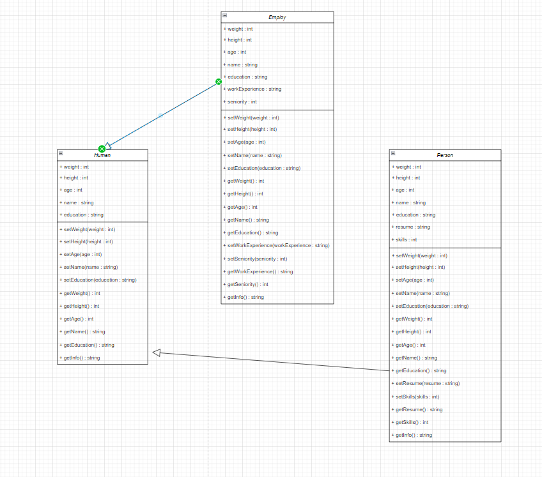

# Вывод

